**IS Assignment 02**

**Insha Javed 21k-3279**

**Muhammad Tahir 21k-4503**

**Task01**

**Code:**

* In Task 1, We were required to calculate the private key(d):
* For this purpose, we defined variables p, q and e.
* Calculated n=p*q and (p-1) * (q-1) = ϕ(n)
* And finally using using formula = d×e≡1mod ϕ(n)
* We used predefined function to perform all the operations
* We’ll free the memory in the end as we defined variables dynamically.

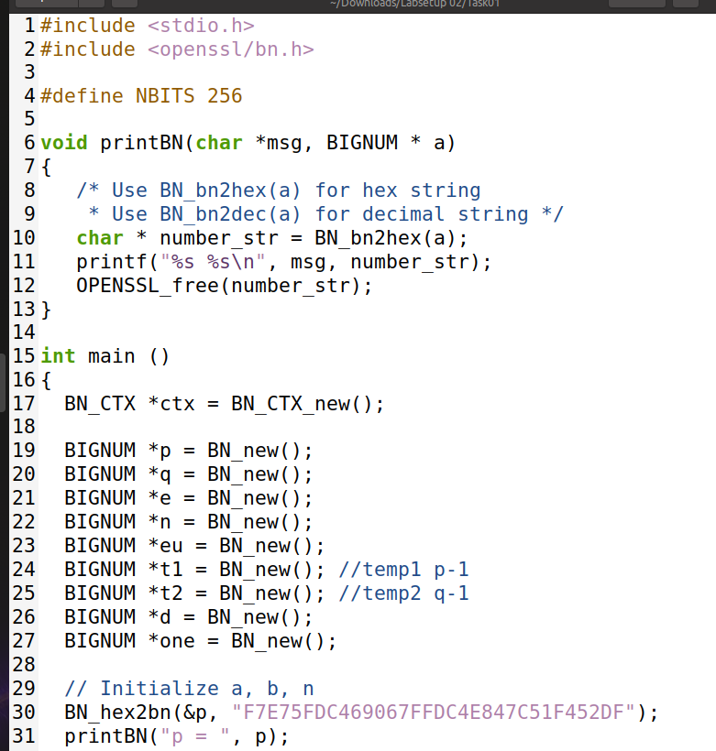

––––––––––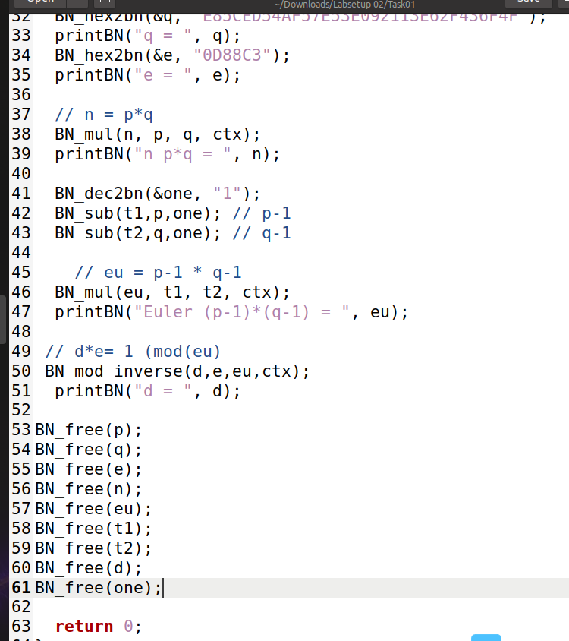

**Output:**

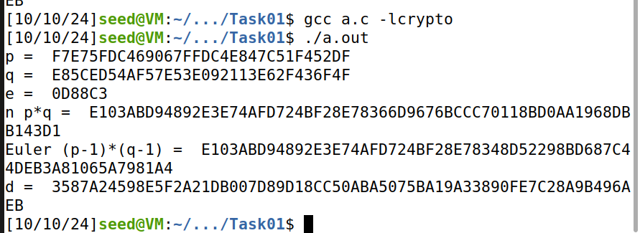

**Task 02**

* In Task 2, we were required to encrypt the message "A top secret!" using the public key (e, n).
* We started by converting the ASCII string to a hexadecimal string.
* To achieve this, we utilized the following Python command to convert the plain ASCII string:
* This resulted in the hex string **4120746f702073656372657421**.
* Next, we converted this hex string to a BIGNUM using the hex-to-bn API BN().
* We used this formula: C=M ^e (mod n)
* Finally, we will free the memory at the end, as we defined variables dynamically.

**Code:**

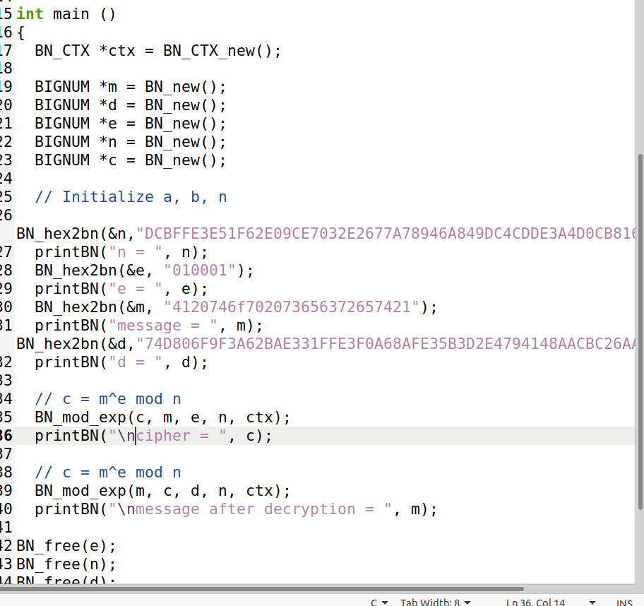

**Output:**

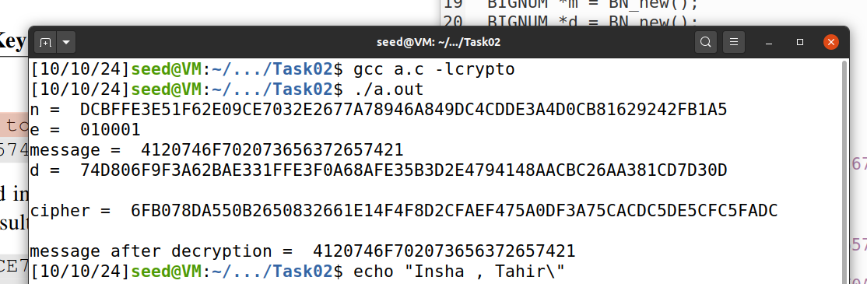

**Task03**

* In Task 3, we were required to decrypt the Cipher Text obtained from question 02, using the private key (e, n).
* We started by converting the ASCII string to a hexadecimal string.
* To achieve this, we utilized the following Python command to convert the plain ASCII string:
* This resulted in the hex string **4120746f702073656372657421.**
* Next, we converted this hex string to a BIGNUM using the hex-to-bn API BN().
* We used this formula: m=C^d (mod n)
* Finally, we will free the memory at the end, as we defined variables dynamically.

**Code:  
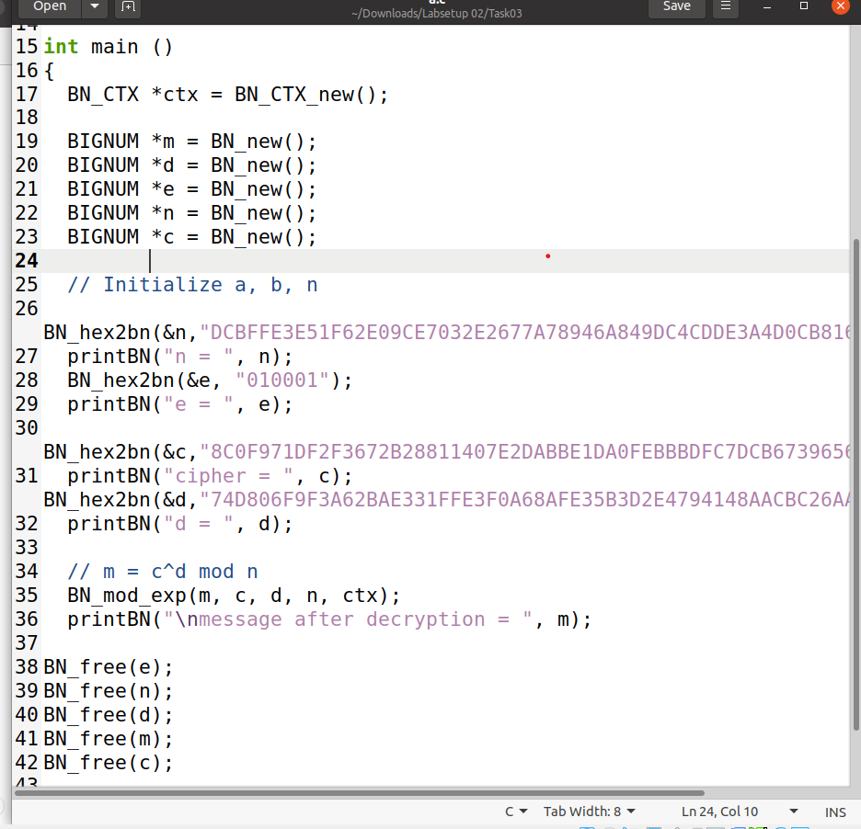**

**Output:**

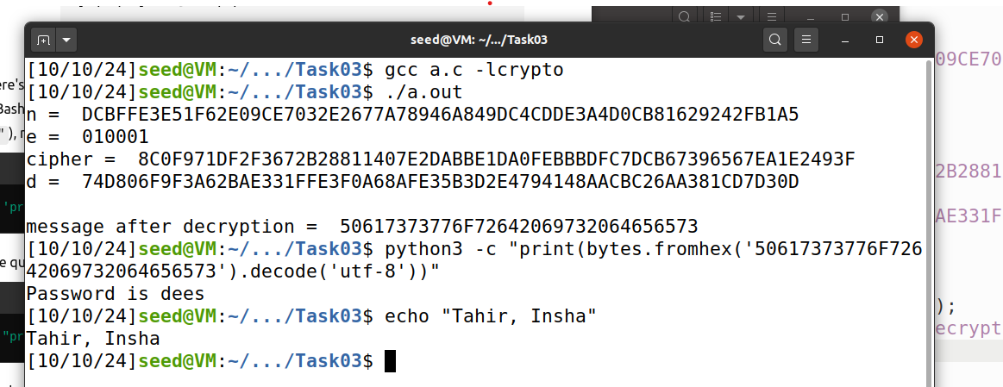

**Task04**

**Observation:**

When signing the messages:

**Original Message1:** "I owe you $2000."

**Signature:** 55A4E7F17F04CCFE2766E1EB32ADDBA890BBE92A6FBE2D785ED6E73CCB35E4CB

**Modified Message2:** "I owe you $3000."

**Signature:** BCC20FB7568E5D48E434C387C06A6025E90D29D848AF9C3EBAC0135D99305822

1. **Unique Signatures:** Each message generates a completely different signature, even with a minor change (from $2000 to $3000). This shows the sensitivity of digital signatures to message content.
2. **Integrity Assurance:** The different signatures ensure that any modification to the message invalidates the original signature, confirming the message's integrity.
3. **Non-reusability:** Signatures are not interchangeable; altering the message results in a distinct signature, preventing fraud.

**Code:**

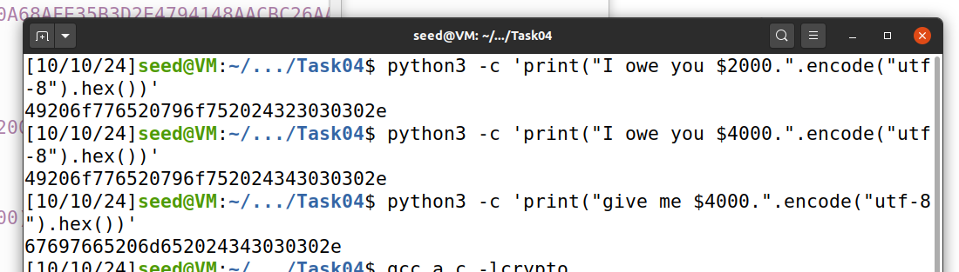

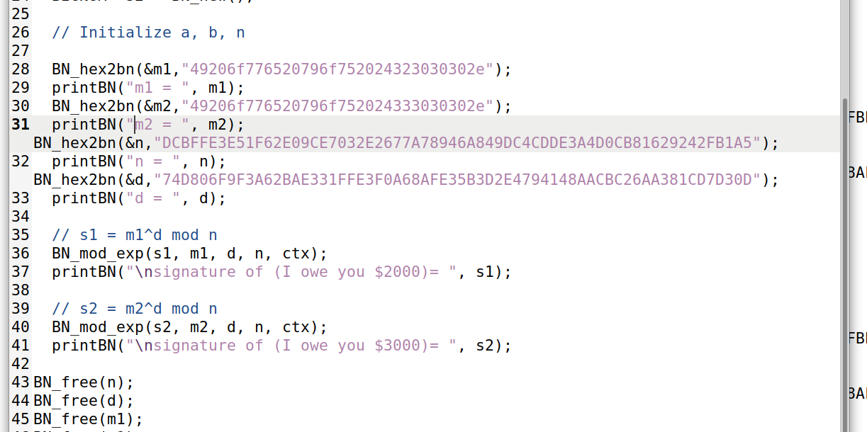

**Output:**

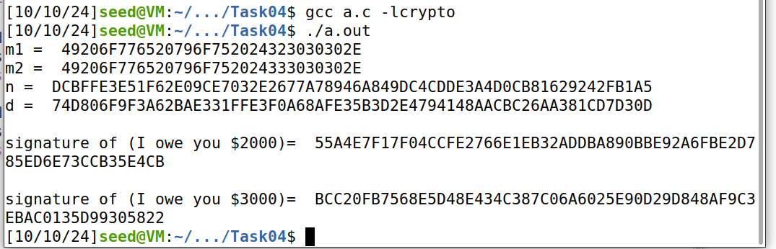

**Task05**

**Observation:**

1. **Initialization:** Think of this as gathering your ingredients. The code sets up "BIGNUM" variables, which are just big numbers needed for the recipe.
2. **Conversion:** It then converts strings of numbers (in hexadecimal form) into these big numbers—like translating a foreign recipe into your language.
3. **Verification:** The heart of the process. It checks if the signature matches the original message, using some clever math (modular exponentiation). Result
4. **Matching:** Finally, it compares the result to see if they’re a match. If yes, the signature is valid; if not, it's a no-go.

**Code:**

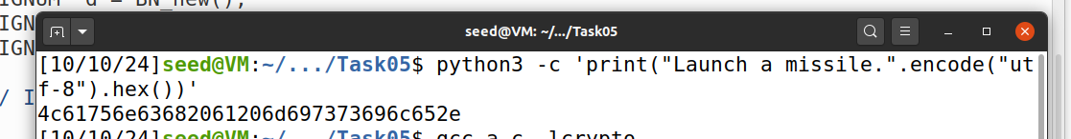

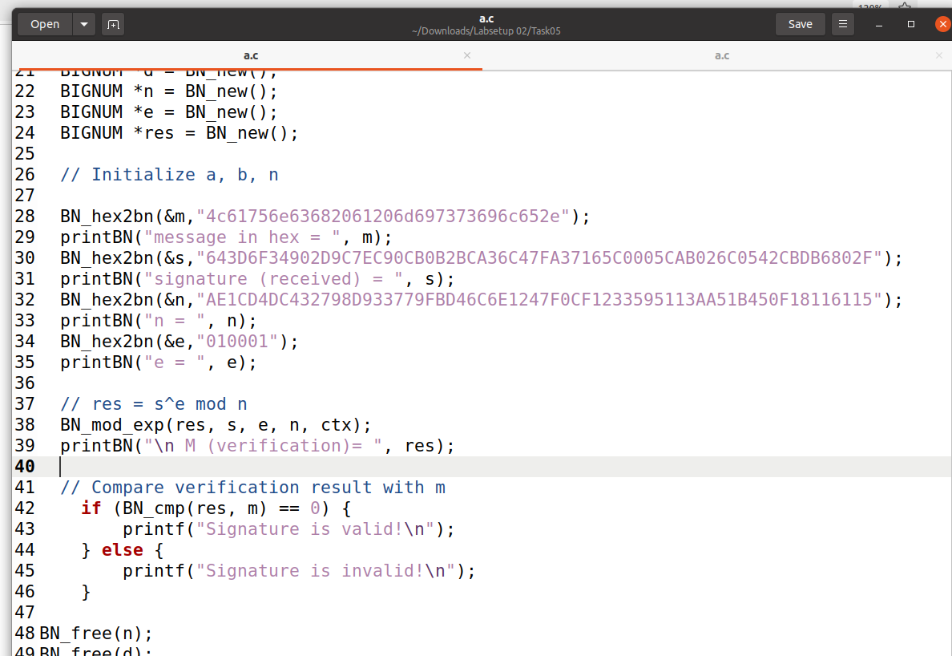

**Output:**

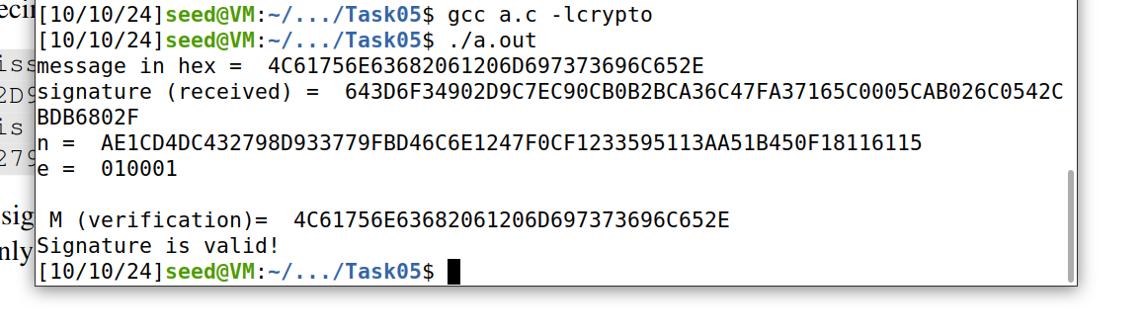

**Now,** Modifying the last 2 bits of the signature:

BN_hex2bn(&s, "643D6F34902D9C7EC90CB0B2BCA36C47FA37165C0005CAB026C0542CBDB6802F");

To

BN_hex2bn(&s, "643D6F34902D9C7EC90CB0B2BCA36C47FA37165C0005CAB026C0542CBDB6803F");

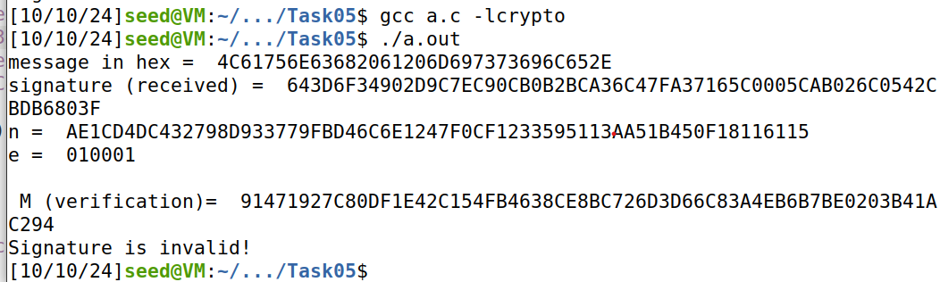

**Task 06:**

**Code:  
File C0:**

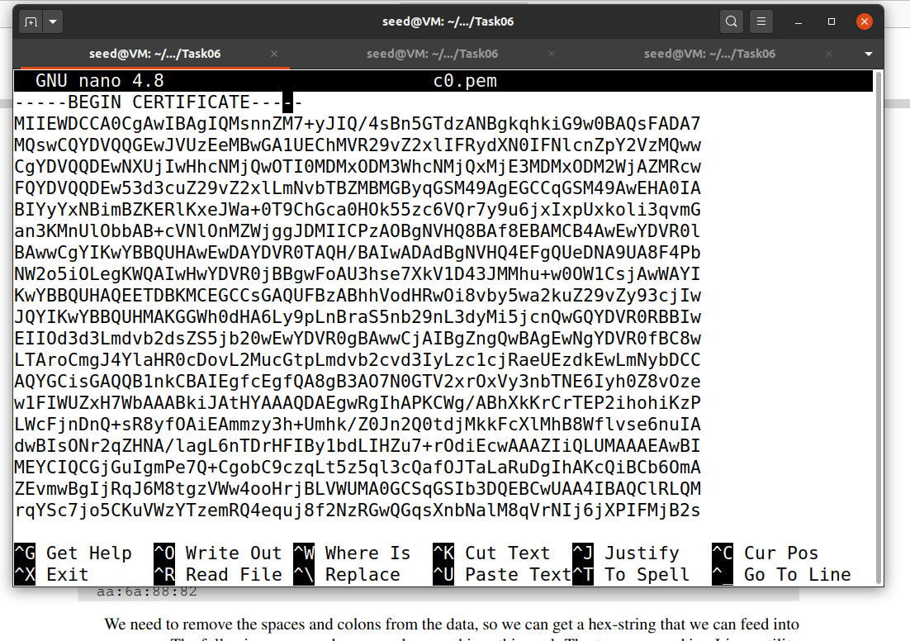

**File C1:  
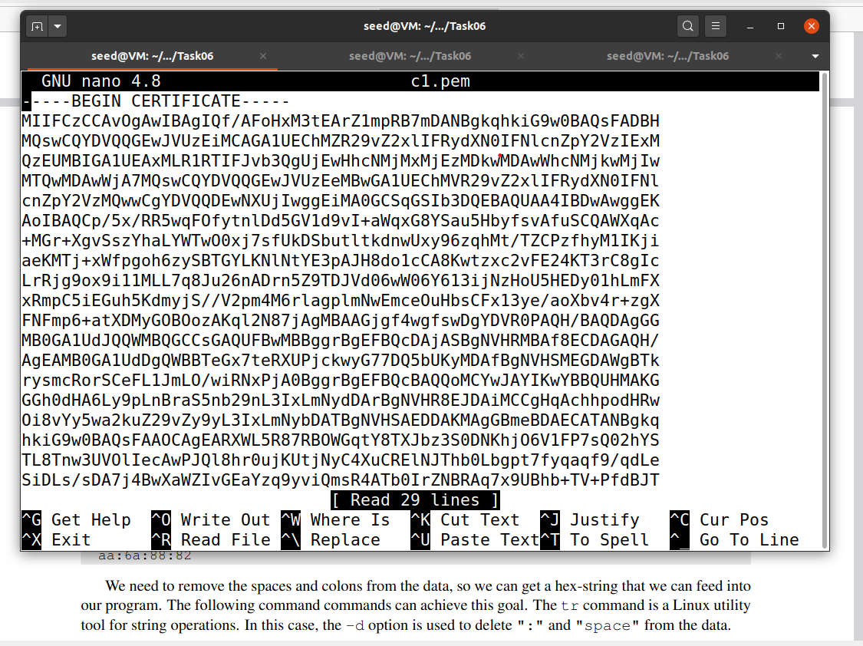**

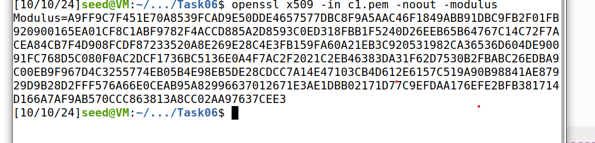

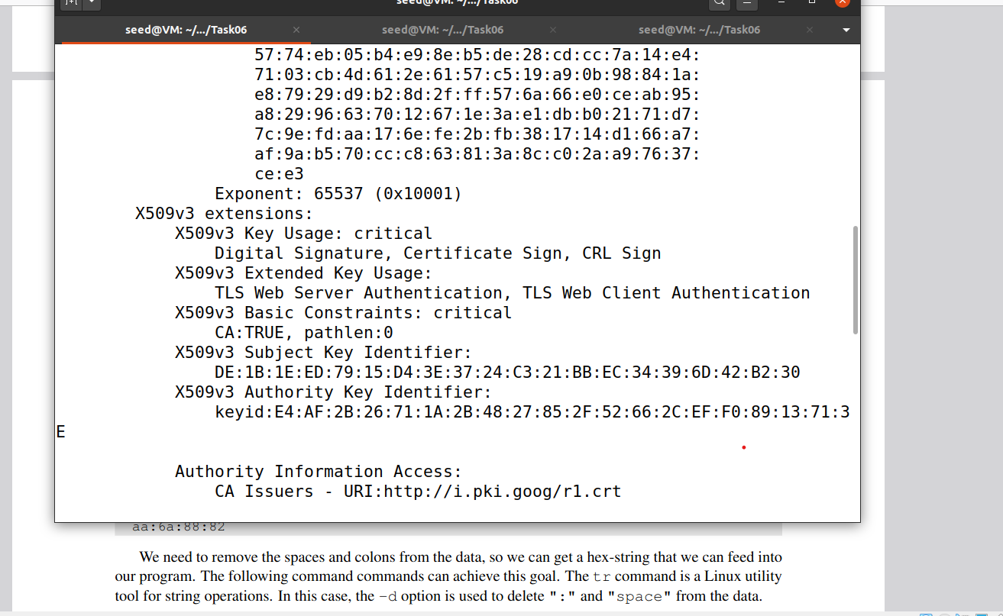

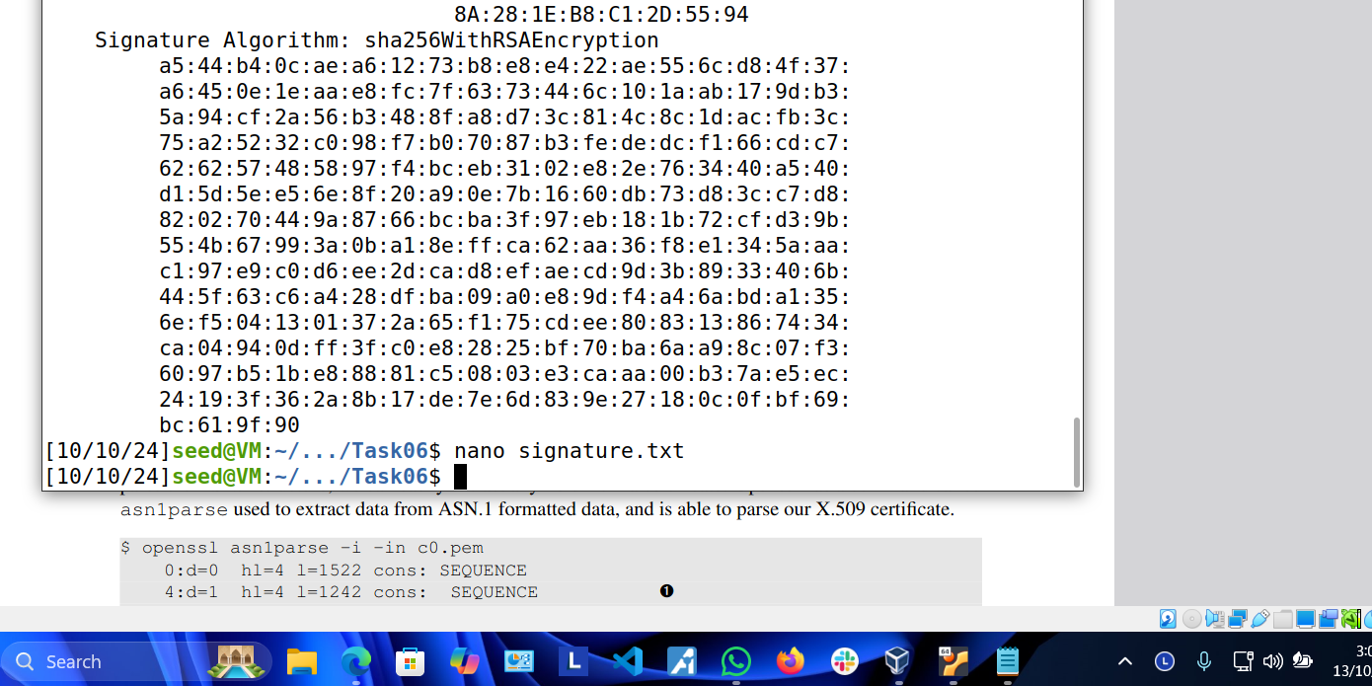

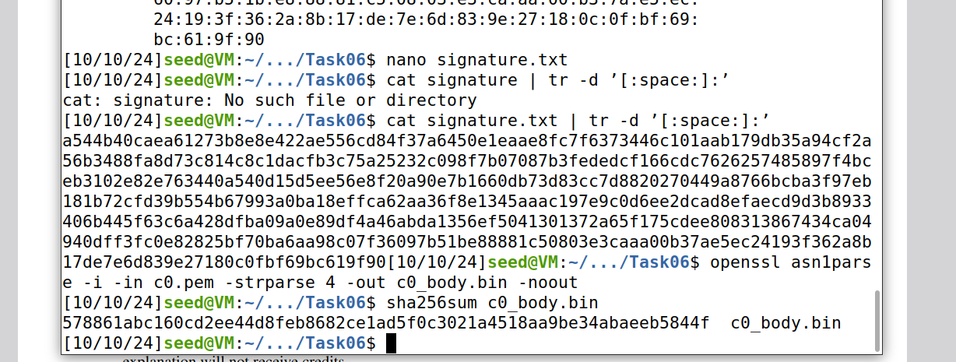

**CODE:**

**Explanation:**  
Here's a minimal explanation of the code:

**1. Initialization:**

Several `BIGNUM` variables are initialized to hold the modulus (`mod_n`), public exponent (`e`), signature, and body hash.

The public key (`mod_n`, `e`), the signature, and the expected hash (`body_hash`) are loaded using `BN_hex2bn`.

**2. Signature Decryption:**

The RSA signature is decrypted using `BN_mod_exp` (which computes `signature^e mod n`).

**3. Hash Extraction:**

The last 32 bytes of the decrypted signature (SHA-256 hash) are extracted using `BN_bn2binpad` directly into a fixed-size array.

**4. Hash Comparison:**

The extracted hash from the decrypted signature is compared with the actual hash (`body_hash`).

If they match, the signature is valid; otherwise, it is invalid.

**5. Memory Cleanup:**

- All allocated `BIGNUM` variables are freed to avoid memory leaks.

This code verifies an RSA signature by decrypting it and comparing the hash in the signature with the expected SHA-256 hash.

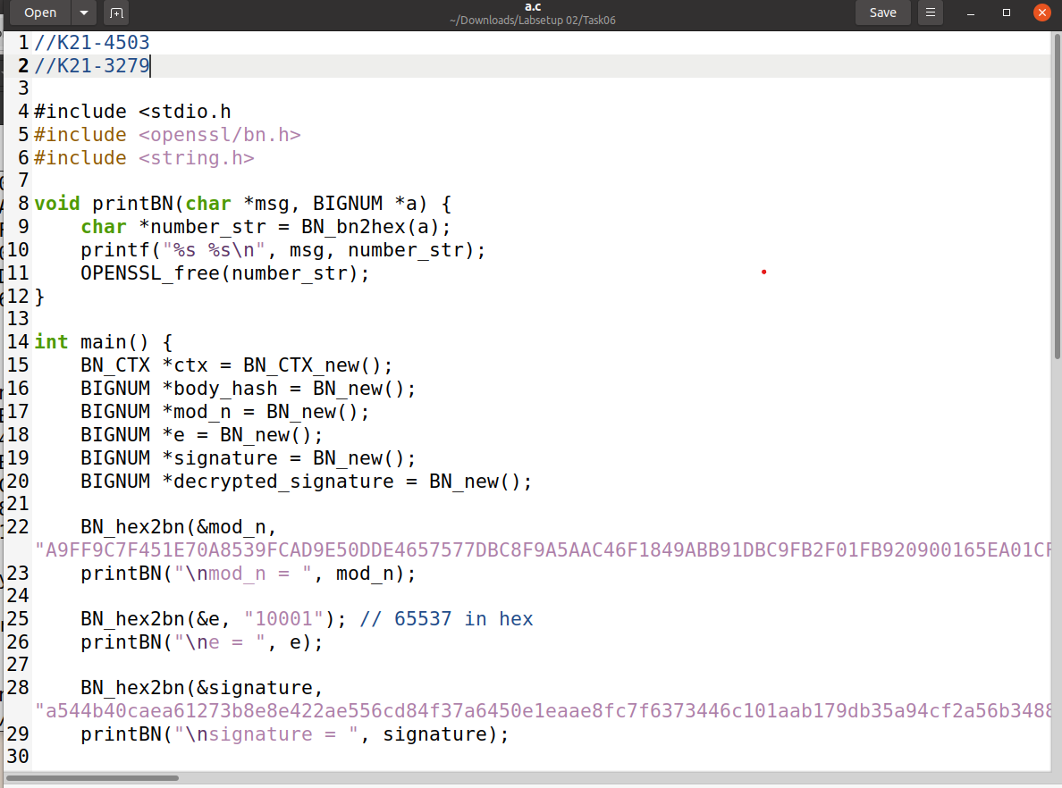

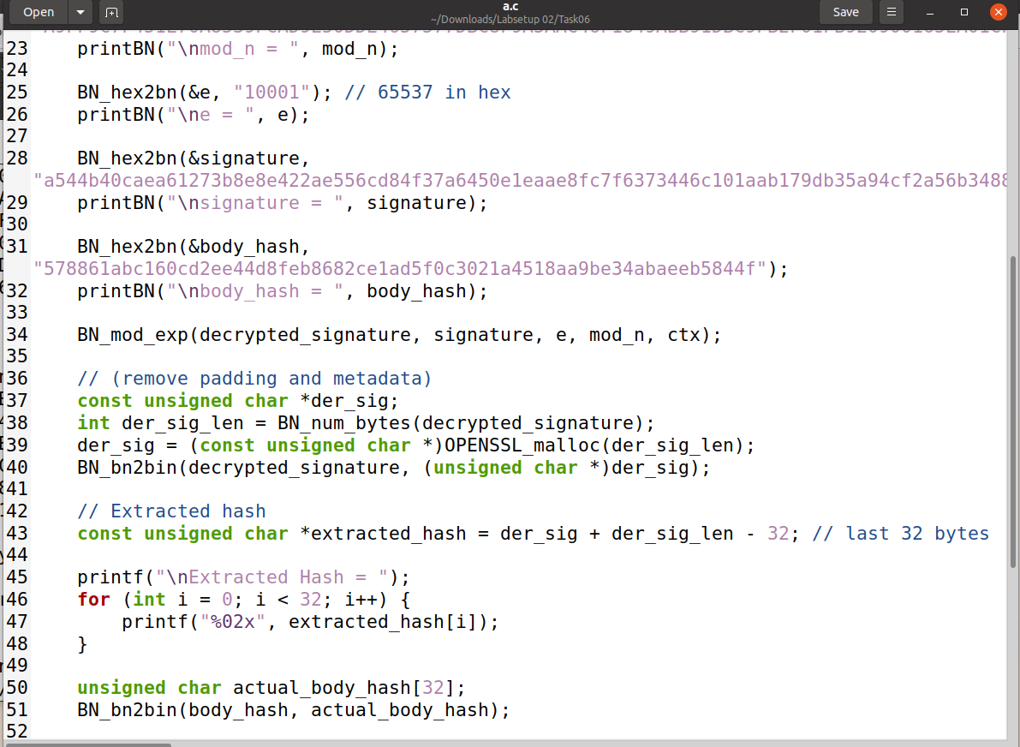

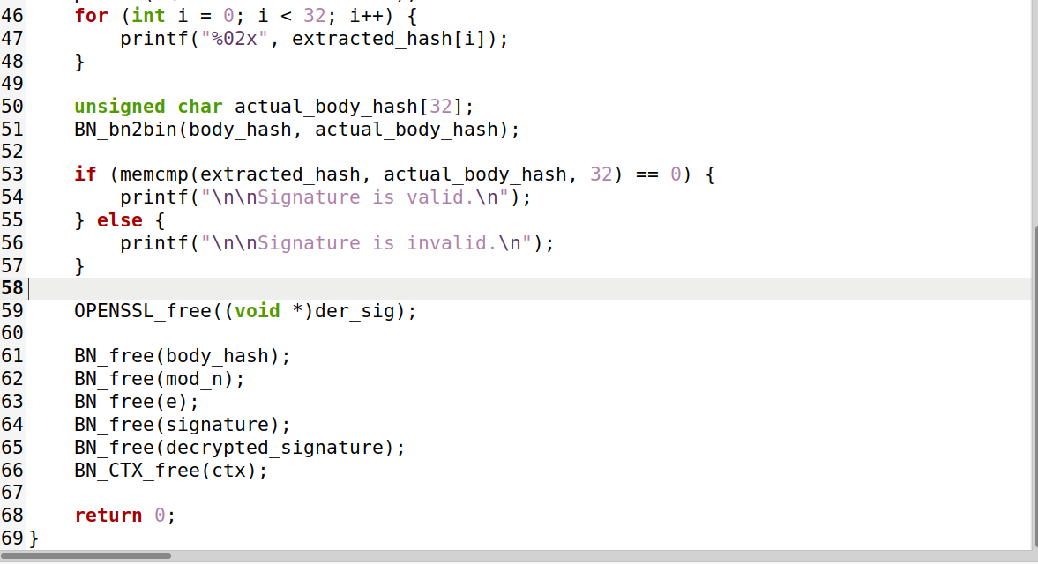

**Output:**

